**Title: Examine files, folders on local hard disk and network drive using FTK Imager**

**Objective:**

The objective of this experiment is to utilize FTK Imager, a digital forensic tool, to examine files and folders on both a local hard disk and a network drive.

**Requirements:**

FTK Imager

Disk or drive for make image

**Procedure/Experiment Steps:**

1. Prepare the Environment: Ensure that the computer meets the system requirements for running FTK Imager. Install FTK Imager on the computer.
2. Launch FTK Imager: Start FTK Imager from the installed location or desktop shortcut.
3. Acquire Local Hard Disk Image: Create an image of the local hard disk using FTK Imager. Follow the provided instructions within the tool to acquire the image.

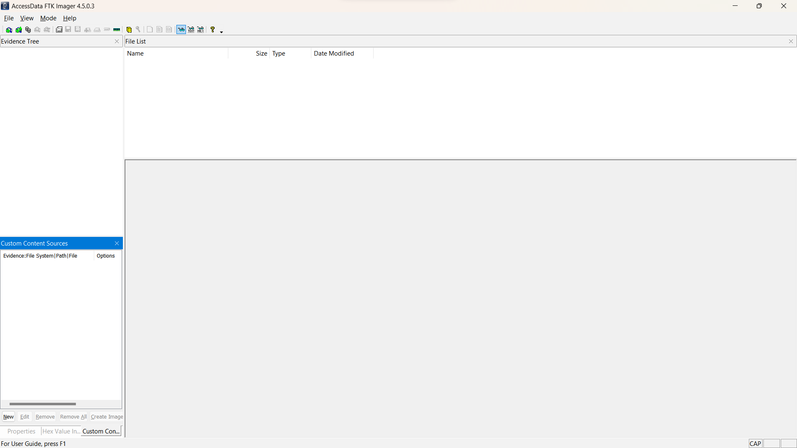

1. Add Local Hard Disk Image: Import the acquired local hard disk image into FTK Imager. This will allow examination of the file and folder structure within the image.

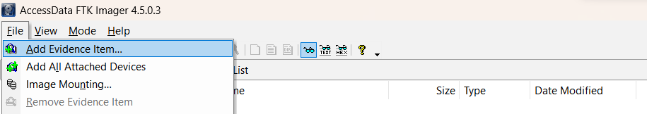

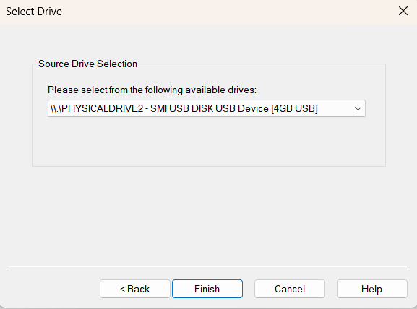

1. File or image in the drive

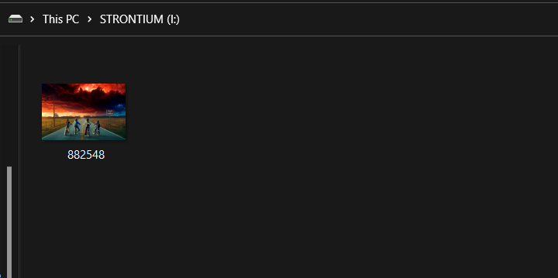

1. Explore Local Hard Disk: Use FTK Imager to navigate through the file and folder structure of the local hard disk image. Examine the files, folders, metadata, and any other relevant information.
2. Export Image file

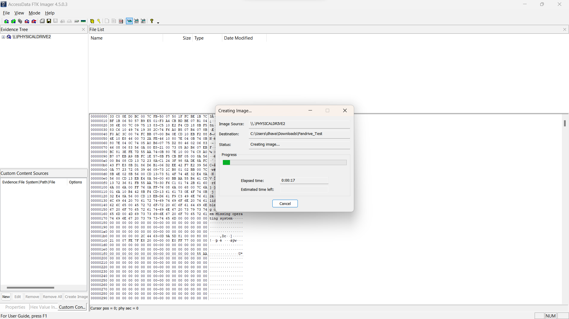

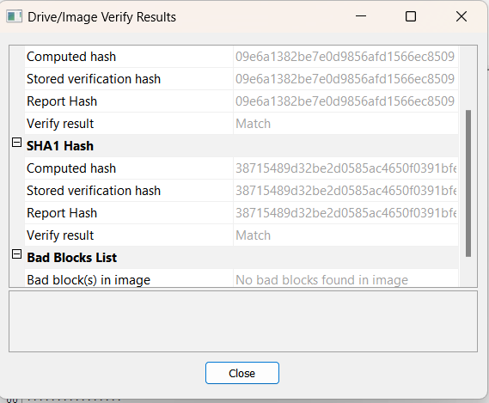

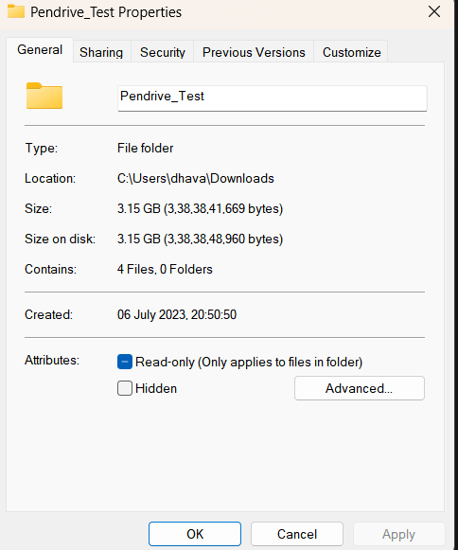

1. Document Findings: Record the details of the examination, including notable files, folders, timestamps, or any other relevant findings or observations.

**Result:**

By utilizing FTK Imager, we successfully examined files and folders on both a local hard disk and a network drive. We acquired images of the local hard disk and network drive, and then imported them into FTK Imager for analysis. Using the tool, we explored the file and folder structures, examined metadata, and documented relevant findings. Notable files, folders, timestamps, and other observed details were recorded for further analysis and reporting.

**Conclusion:**

FTK Imager is an effective digital forensic tool for examining files and folders on local and network drives. Through its image acquisition and analysis capabilities, we were able to navigate and explore the file systems of both the local hard disk and the network drive. FTK Imager proves to be a valuable asset in digital forensic investigations, data recovery processes, and file system analysis.

**Future Scope:**

1. Advanced metadata analysis: Utilize FTK Imager's metadata extraction capabilities to gather and analyze extended file attributes, timestamps, file permissions, and other relevant information.
2. Carving and recovery techniques: Explore FTK Imager's file carving and recovery features to extract deleted or hidden files from acquired images.
3. Timeline analysis: Perform timeline analysis using FTK Imager to establish a chronological order of file creation, modification, or access events.
4. Integration with other forensic tools: Explore the integration of FTK Imager with other digital forensic tools to enhance analysis and cross-validation of findings.
5. Stay updated with FTK Imager: Regularly update FTK Imager to benefit from the latest features, improvements, and support for new file system formats, ensuring efficient and accurate file and folder examination.